The FACTS for REALTORS - NAR SETTLEMENT
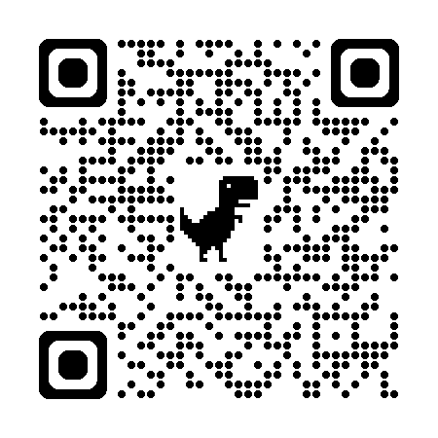https://www.nar.realtor/the-facts
Competition.Realtor - The site for NAR Settlement Facts
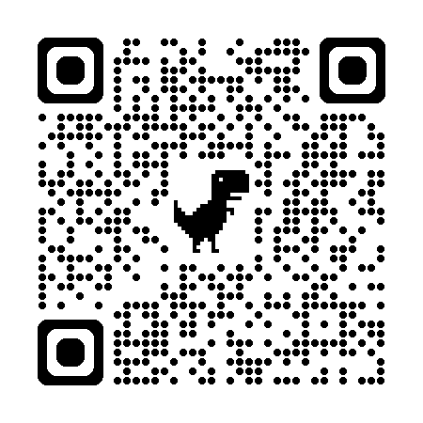https://www.nar.realtor/competition-in-real-estate
The Advocacy Scoop Podcast
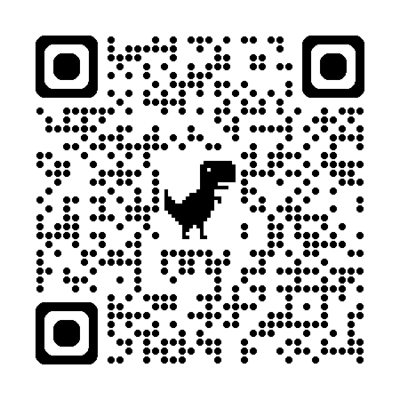https://www.nar.realtor/advocacy/advocacy-scoop-podcast
INVEST IN RPAC
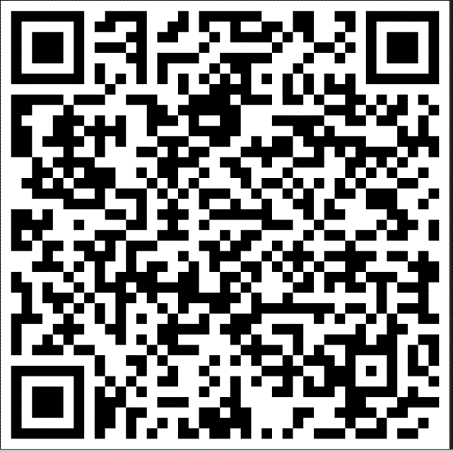
https://ai360.aristotle.com/AI360FormBuilder/(S(zpxsb52uyzk13ckewgxqhren))/Login.aspx?mobile=true
REALTORS Give Back
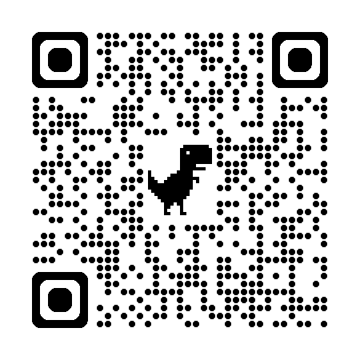https://netar.us/members/giving-back/#submitgood

NETAR'S EVENTS & EDUCATION CALENDAR
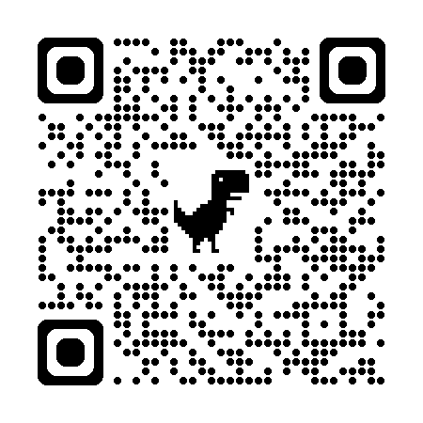https://netar.us/events-landing/
Become an ABR REALTOR
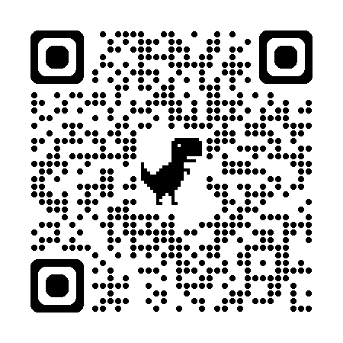https://become.abr.realtor/
ACCREDITED BUYER REPRESENTATIVE (ABR) 2-DAY COURSE - BROKERS
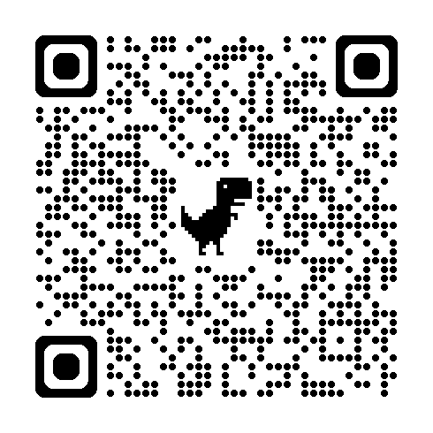
https://netar.us/event/broker-accredited-buyer-representativeabr-2-day-course-16tn-ce-hybrid-2/2024-05-29/
ACCREDITED BUYER REPRESENTATIVE (ABR) 2-DAY COURSE - AGENTS
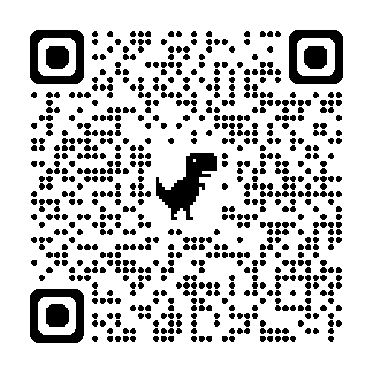
https://netar.us/event/broker-accredited-buyer-representativeabr-2-day-course-16tn-ce-hybrid/2024-06-17/
NETAR'S FACEBOOK PAGE
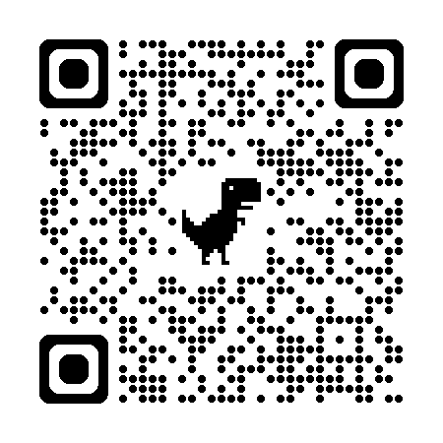
https://www.facebook.com/netarrealtors/

NETAR'S BUSINESS PARTNERS
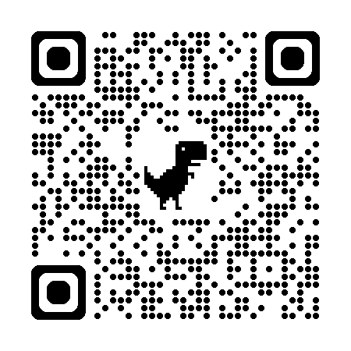
https://netar.us/community/business-partners/
NETAR'S "LET'S TALK" SPEAKING ENGAGEMENT RECORDINGS

https://www.facebook.com/netarrealtors/videos
TENNESSEE REAL ESTATE COMMISSION ("TREC")
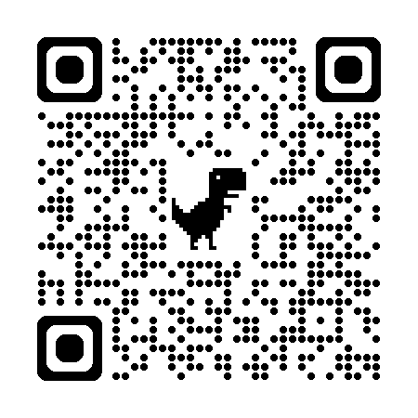
https://www.tn.gov/commerce/regboards/trec.html
REALTORS RELIEF FOUNDATION ("RRF")
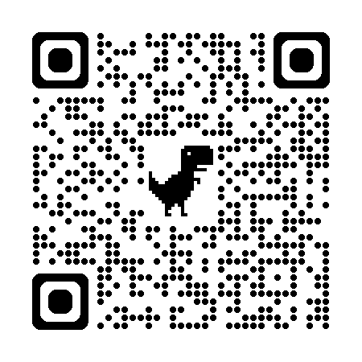
https://rrf.realtor/

